**RIYA INDAP,44**

**Motherboard**

A computer’s motherboard is typically the largest printed circuit board in a machine’s chassis. It distributes electricity and facilitates communication between and to the central processing unit (CPU), random access memory (RAM), and any other component of the computer’s hardware.

**Types of motherboard:**

1.advanced technology(AT) motherboard: The power connections on these motherboards are in the form of sockets and plugs with six prongs each. Due to the difficulty in recognizing these power connections, users often have issues while trying to connect and operate them.It’s larger physical size makes it more difficult to install new [hardware drivers.](https://www.spiceworks.com/tech/devops/articles/what-is-device-driver/)

2.Standard ATX motherboard: Unlike AT, it is much more compact and enables the associated components to be interchanged.

3.Micro ATX motherboard: The length and width of these motherboards, measured in millimeters, are also 244 mm. This motherboard has fewer ports and slots than the Standard ATX board.

4.Extended ATX motherboard: The dimensions of this motherboard are 344 millimeters by 330 millimeters. This motherboard supports a single or a twin CPU configuration and has up to eight RAM slots.

5.BTX motherboard: BTX, is a strategy developed to fulfill the requirements of emerging technologies, which call for increased power consumption and, as a result, emanate more heat.

6.Mini ITX motherboard: It was developed in the 2000s, and its measurements are 17 by 17 centimeters. Due to its reduced power consumption and quicker cooling capabilities, it is primarily used in computers with a small form factor (SFF).

**Components:**

1.Mouse and Keyboard connectors: Computer motherboards must have two separate connectors that allow users to connect their external mouse and keyboard. These connectors are responsible for sending instructions and receiving responses from the computer. There are two keyboard and mouse connectors, the PS/2 and the USB. The personal system/2(PS/2) port is a mini-DIN plug that contains six pins and connects the mouse or keyboard to an IBM-compatible computer.

2.Universal Serial Bus(USB): The USB is a computer interface that connects computers to other devices, such as phones. The USB port is a significant part of a motherboard that allows users to connect external peripheral devices such as printers, scanners, and pen drives to the computer. Moreover, it enables users to transfer data between the device and the computer.

3.CPU: The central processing unit (CPU) is commonly referred to as the computer’s brain. The CPU controls all the functions of a computer. CPUs are available in different form factors, each requiring a particular slot on the motherboard.

4.RAM memory slot: RAM slots connect the random access memory (RAM) to the motherboard. RAM allows the computer to temporarily store files and programs that are being accessed by the CPU. A computer usually has two RAM slots. However, some computers have up to four RAM slots in the motherboard to increase the available memory.

5.Basic Input/Output system: The BIOS contains the [firmware](https://www.spiceworks.com/tech/devops/articles/what-is-firmware/) of the motherboard. It consists of instructions about what to do when the computer is turned on. It is responsible for initializing the hardware components and loading the computer’s operating system. The BIOS also allows the computer’s operating system to interact and respond with input and output devices such as a mouse and keyboard.

6.Chipset: The chipsets of a computer control how the computer hardware and buses interact with the CPU and other components. Chipsets also determine the amount of memory users can add to a motherboard and the type of connectors that the motherboard can have.

7.Cooling Fans: The heat generated when electric current flows between components can make a computer run slowly. If too much heat is left to build up unchecked, it could damage computer components. Thus, a computer performs better when kept cool. Cooling fans increase the airflow, which helps to remove heat from the computer. Some elements, such as video adapter cards, have dedicated cooling fans.

8.Adapter Cards: Adapter cards are integrated into the motherboard to enhance a computer’s functionality. Examples include sound and video adapters. The expansion slots allow users to install compatible adapter cards.

9.CMos battery: The CMOS battery is a small round battery found on the motherboard of every computer. It provides power to the complementary metal oxide semiconductor (CMOS) chip. The CMOS chip stores BIOS information and computer settings, even when powered down. The CMOS battery allows users to skip resetting BIOS configurations, such as boot order, date, and time settings, each time they power on their computer.

10.Storage devices: Storage drives store data permanently or retrieve data from a media disk. The storage devices can either be installed in the computer as hard drives or in removable drives that can connect to the computer through the USB ports.

11.Front Panel connectors: Front panel connectors connect the light-emitting diode (LED) lights on the front of the case to the hard drive, the power button, the reset button, and the internal speaker for testing. Some USB and audio devices also have LED lights.

12:Power connectors: The power connector provides an electric supply to the computer to function as intended. The power supply connector has 20 pins and converts 110-V AC power into +/-12-Volt, +/-5-Volt, and 3.3-Volt direct current (DC) power.

**Northbridge & Southbridge:**

* northbridge:The data connections to the CPU, RAM, or PCIe are made through the northbridge component. The operations performed by the RAM are first “interpreted” by the CPU as being output after the RAM begins to deliver inputs to the CPU. After being written to the PCIe, the data is either copied or moved to the expansion card, based on the kind of card you have.
* Southbridge:The data connection to the [basic input/output system (BIOS)](https://www.spiceworks.com/tech/devops/articles/what-is-bios/), the universal serial bus (USB), the serial advanced technology attachment (SATA), and the PCI bus are managed by the southbridge component. Your computer can start up because of signals sent to the BIOS, and the data sent to the SATA “awakens” your optical, hard disc, and solid-state drives. The video card, network card, and sound card receive power from the information stored on the SATA.

**Gigabyte Micro ATX motherboard’s features:**

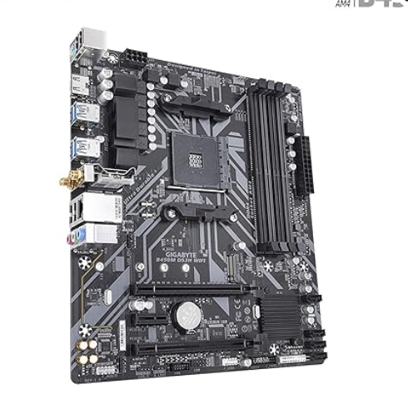

* Chipset Type: AMD B450
* Compatible Processor type: AMD Ryzen 5000 series/ 3rd Gen Ryzen/ 2nd Gen Ryzen/ 1st Gen Ryzen
* Processor Socket: Socket AM4
* Video and Graphics: PCI Express
* Memory: DDR4,RAM memory max -128GB,storage capacity-64GB
* Dimensions: 26.49 x 26.49 x 5.41 cm
* Extra features:

1.RGB FUSION 2.0 with Addressable RGB & RGB LED Strips Support

2.Dual Channel Non-ECC Unbuffered DDR4, 4 DIMMs

3.High Quality Audio Capacitors and Audio Noise Guard Design